Hooli XYZ

**Sprint 1 Report**

**Sprint Period:** 07/03/2016 – 21/03/2016

**Members:**

Connor Beardsmore – 15504319

Brendan Lally – 18407220

Adam Brown – 18338993

Jordan Chou – 18348691

Edward Lim - 18339145

**Table of Contents:**

1. Sprint Planning
2. SCRUM Meetings
3. Sprint Review
4. Sprint Retrospective

Appendix A: CSV of all user stories

Appendix B: Screenshots of Functionality

**1. Sprint Planning**

**User Stories:**

The following user stories were selected for completion in Sprint 1.

|  |  |  |  |
| --- | --- | --- | --- |
| Number: | User Story: | Area: | Effort Points: |
| 1 | As an Admin, I want to access an Admin platform so that I can perform administrative actions. | Admin | 5 |
| 2 | As an Admin, I want to create user profiles so that users can use my site effectively. | Admin | 3 |
| 3 | As an Admin, I want to reset passwords so that I can help users regain access to their accounts. | Admin | 2 |
| 4 | As a User, I want to login to the platform so that I can post a submission. | Accounts | 3 |
| 5 | As a User, I want to be able to change my password so that I can be more secure. | Accounts | 2 |
| 6 | As a User, I want to logout of my account so that nobody can access my account. | Accounts | 3 |
| 7 | As a User, I want to create an account so that I can use the platform. | Accounts | 5 |

**Sprint Goal:**

The goal of Sprint 1 was to initialize and setup the base online platform for both users and administrators to access. This goal is reflected by our choice of user stories designated in the sprint backlog. All user stories for Sprint 1 involve the ability for users and admins to both access the site and log into/out of an online user account.

**Task Breakdown:**

The user stories for the sprint were broken down into simpler high-level task units. These tasks must be finished before the user stories can be reviewed, accepted and completed:

* Set up BitBucket repository.
* Set up initial Django base server.
* Create database for users.
* Create login page.
* Create registration page.
* Create registration form.
* Create homepage
* Create homepage template.
* Create Administrator platform.
* Create change password form.
* Create change password template.
* Create a page dashboard.

**Task Distribution:**

|  |  |
| --- | --- |
| Members: | Area of Focus: |
| Connor | Setup Environment. Documentation. |
| Jordan, Adam | User Accounts. Stories (4) (5) (6) (7). |
| Brendan, Edward | Admin Platform. Stories (1) (2) (3). |

**Effort Estimation:**

The initial setup for the platform is very time-intensive and thus, our effort estimations were relatively high. In the future, we expect effort estimations to be much lower as additional functionality is extended. The estimation points are based upon a Fibonacci scale (1,2,3,5,8,13) and the values were agreed upon via discussion in our initial sprint planning session.

**Definition of ‘Done’:**

The team’s definition of ‘done’ was discussed within the planning stage and will be further discussed and modified at every upcoming sprint. Typically, we would include approval by Project Client in the acceptance criteria. However, due to the limited times we can meet with the Project owner, this is unfeasible. A story is considered completed if it meets the following criteria:

* Code Complete
* Testing Complete
* Code Documented
* All Code Peer Reviewed

**Project Management:**

The team will utilize the online “Pivotal Tracker” software as a project management tool during the course of the project. All user stories and related data covered within the sprint reports will be reflected by the data within Pivotal Tracker. The tool will also be employed to create valuable statistics and figures for use within the sprint reviews.

**2. SCRUM Meeting**

**Meeting #1 : 21/03/16**

**Attendance : Connor, Jordan, Adam, Brendan, Edward**

|  |  |  |  |
| --- | --- | --- | --- |
| Members: | Completed | Uncompleted | Issues |
| Connor | Setup Environment. Documentation | - | - |
| Jordan, Adam | User Accounts. (4) (5) (6) (7) | - | - |
| Brendan, Edward | Admin Platform. (1) (2) | Rest Passwords. (3) | Lack of Email server. Cannot email users a reset password code. |

**3. Sprint Review**

**Completed User Stories:**

* As an Admin, I want to access an Admin platform so that I can perform administrative actions.
* As a User, I want to login to the platform so that I can post a submission.
* As a User, I want to logout of my account so that nobody can access my account.
* As a User, I want to create an account so that I can use the platform.
* As a User, I want to change my password so that I can be more secure.
* As an Admin, I want to create user profiles so that users can use my site effectively.

**Unfinished User Stories:**

* As an Admin, I want to reset passwords so that I can help users regain access to their accounts.

**Review Data:**

* Total Stories: 45
* Completed: 6
* Uncompleted: 39
* Total Progress: 13%

**Review Data:**

The statistics and data within the figures below were produced via the Pivotal Tracker software utilized by the team. They illustrate the progress throughout the current iteration and progress towards the final release.

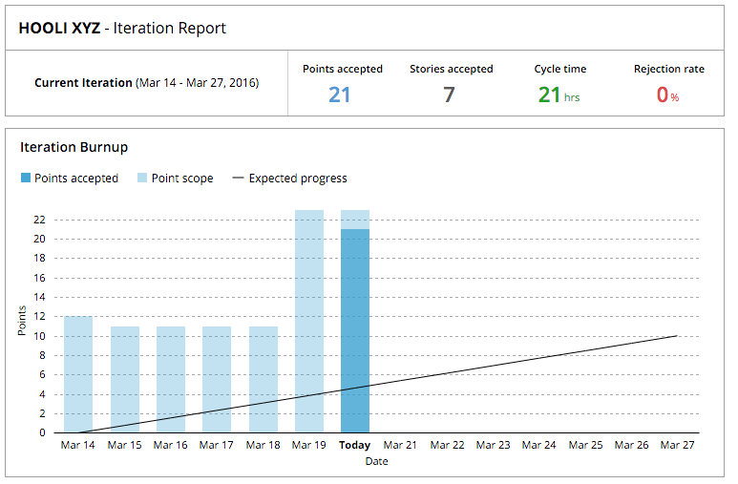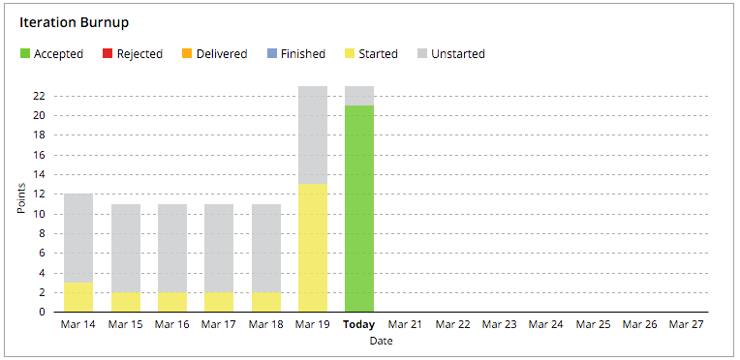

Figure 1: Iteration Burnup – Points and Stories

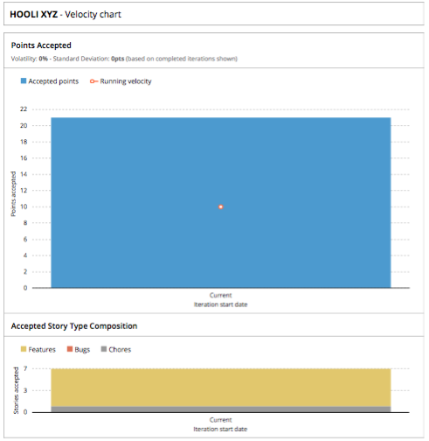

Figure 2: Velocity Chart

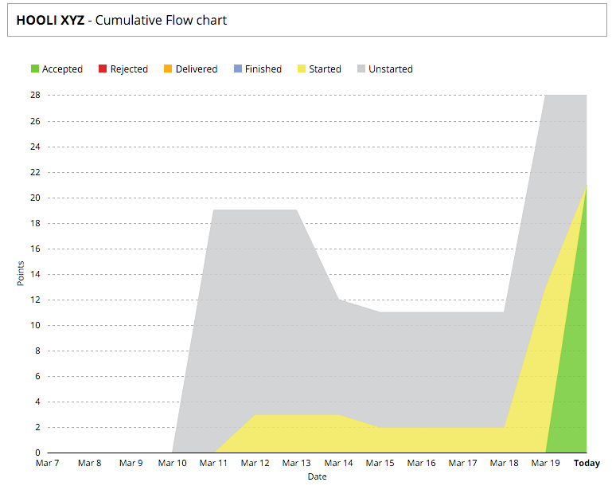

Figure 3: Cumulative Flow Chart

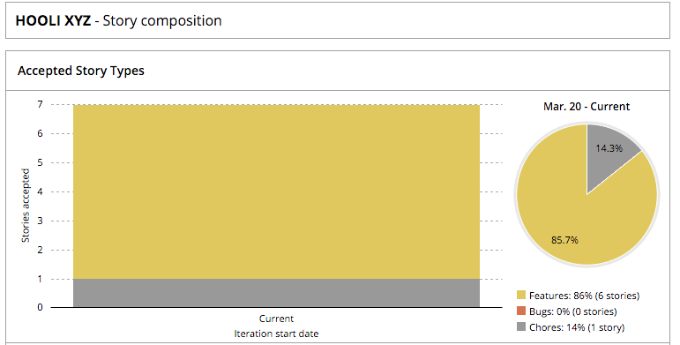

Figure 4: Story Composition

**4. Sprint Retrospective**

**Sprint Ratings**

* Communication: 9/10
* Performance: 8/10
* Work Ethic: 8/10

**What went well?**

Several factors worked well within our group for Sprint 1. The team’s motivation and work ethic was very high with a strong desire to get started on the project. Team meetings were easy to schedule due to team members availability. This was also helped by the strong communication between all team members. Team members worked on user stories in pairs and we found this to be very productive. The high completion rate of user stories within the iteration was also notable. Learning how to utilize the tools we are used for the platform has been a steep learning curve. Nevertheless team members have adapted well to this setback.

**We want to keep doing:**

The team will continue to hold weekly meetings on Mondays, subject to the availability of team members. Stories will also continue to be worked on in pairs to keep efficiency as high as possible. The team’s performance in relation to stories completed was strong in this iteration and we want to keep this level of performance and quality throughout the remaining sprints.

**What did not go well?**

The majority of the Project Design and SCRUM methodology concepts undertaken within the sprint are new to everybody in the team. It has taken some time to adapt to these techniques and thus, the team’s progress was somewhat slower than expected. Preparation for the start of the sprint was poor and this resulted in the first week being under-utilized. This added further time constraints given the short length of the sprint in comparison to the next two upcoming sprints. This put additional pressure onto the team to finish the user stories. Delegation of tasks could also have been improved, with some team members being under-utilized, with others having a larger workload.

**We want to start:**

In addition to the weekly progress meetings, we may also start holding small SCRUM meetings throughout the week to further clarify our progress. For the next sprint, we will improve our performance by aiming to hold at least 3 full meetings. We also aim to complete an extra 4 user stories within the next sprint.

**Appendix B: Screenshots of Functionality**

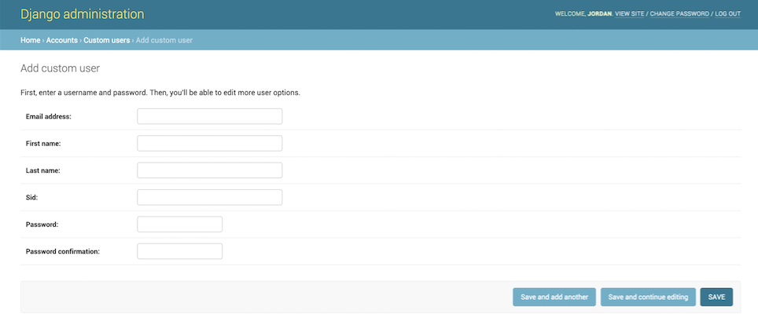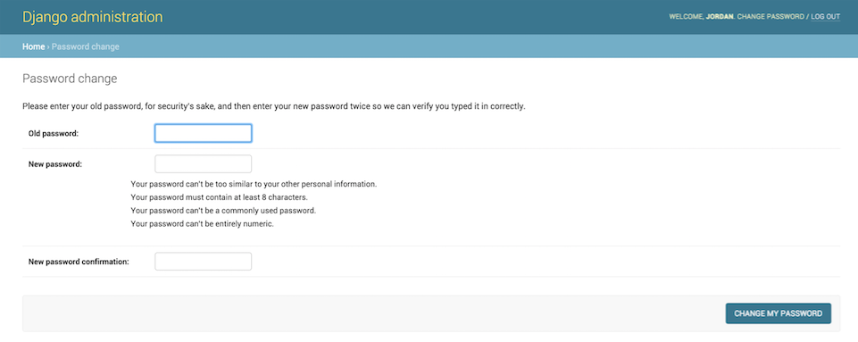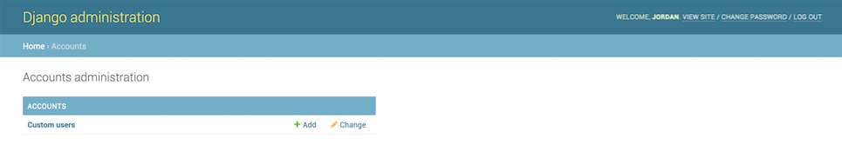

Figure 5: Admin Home Page Screenshot

Figure 6: Admin Add User Screenshot

Figure 7: Admin Add Change Password Screenshot

Figure 8: User Register Screenshot

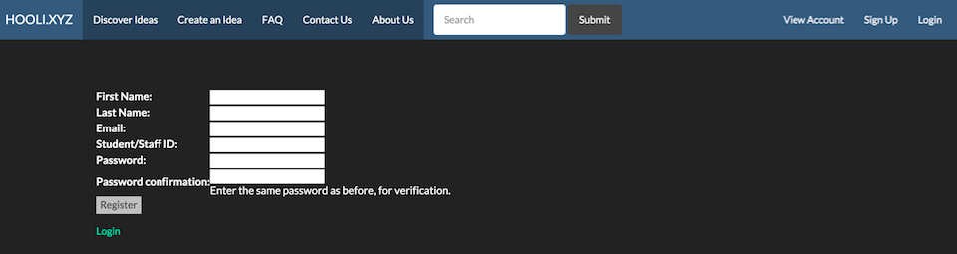

Figure 9: User Login Screenshot

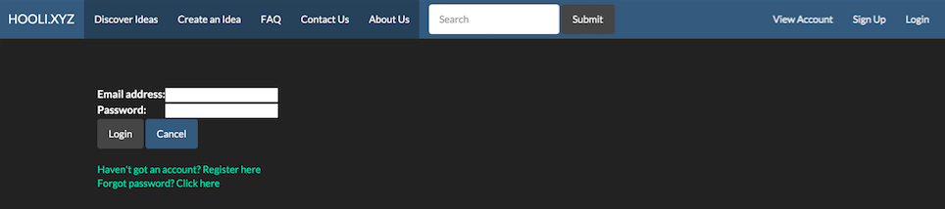

Figure 10: User Change Password Screenshot

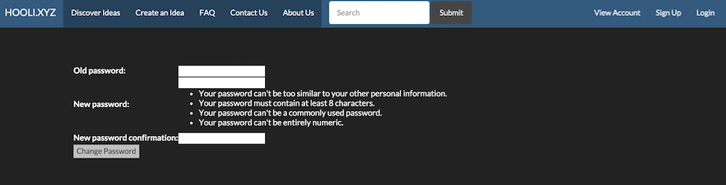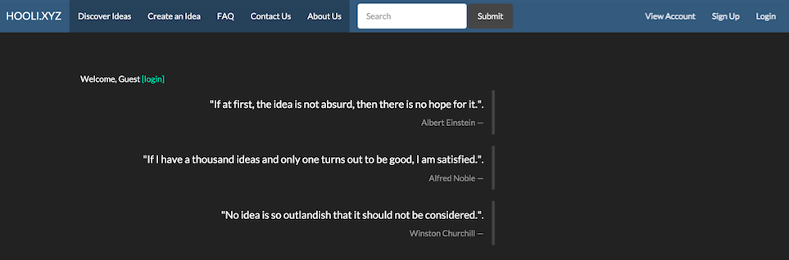

Figure 11: Home Page Screenshot